Some of the primary foundations of our current understanding of gender are that 1) it is a [Western concept](https://www.academia.edu/2259929/Colonialism_Two-Spirit_Identity_and_the_Logics_of_White_Supremacy), 2) it is not binary, and 3) it is not the same as sexual orientation.

## Easy as Pie: Baseline Procedures

* Any introductions should include references to gender pronouns.
  + “Hello, I’m [name], and my pronouns are [Possible Pronouns].”
* Nametags or name cards should include gender pronouns or identify designation used in the individual’s own culture.
* Adhering to someone’s gender pronouns should be a strict policy all participants should abide by.
* Do not put anyone on the spot about their non-normative gender. You can approach them privately and see if they wish to spend their time and energy educating others. This is not their job and should not be expected however.

## Common Sense Doesn’t Always Make Sense

### Western Concept

Western civilization and the spread of imperialism is the foundation of what is commonly understood to be gender. Western Science shows conclusively that gender is not binary, yet it has resulted in the medicalization of nonbinary bodies and the forcing of one of two genders on infants.

There are many cultures that exist without a language around gender. Other cultures embrace multiple genders, including the Objima tribe that shares that there is a [Two-Spirit](https://en.wikipedia.org/wiki/special:search/Two-spirit) gender category.

"While most people mistakenly associate the term with "LGBT Native", the term and identity of two-spirit "does not make sense" unless it is contextualized within a Native American or First Nations framework and traditional cultural understanding."

*Source: Two-spirit -* [*https://en.wikipedia.org*](https://en.wikipedia.org/wiki/special:search/Two-spirit)

It is important to recognize that while Western culture uses gender to categorize people in response to an assumed hierarchy, many third-gender (fourth-gender, and so on) categories for other cultures is a spiritual and/or ceremonial designation, or serve some other function that is not considered as central to a personal’s identity as it is considered in modern society.

### !Binary

"Intersex people are born with any of several variations in sex characteristics including chromosomes, gonads, sex hormones, or genitals that, according to the UN Office of the High Commissioner for Human Rights, "do not fit the typical definitions for male or female bodies". Such variations may involve genital ambiguity, and combinations of chromosomal genotype and sexual phenotype other than XY-male and XX-female.  
  
  
  
Intersex people were previously referred to as hermaphrodites, "congenital eunuchs", or congenitally "frigid". Such terms have fallen out of favor; in particular, the term "hermaphrodite" is considered to be misleading, stigmatizing, and scientifically specious. Medical description of intersex traits as disorders of sex development has been controversial since the label was introduced in 2006."

*Source: Intersex -* [*https://en.wikipedia.org*](https://en.wikipedia.org/wiki/special:search/Intersex)

This is the Western scientific and political definition of nonbinary genders. Of course, gender involves more than what is evident in biology, and challenges to gender expression is often about not adhering to defined cultural gender roles.

### Gender != Sexual Orientation

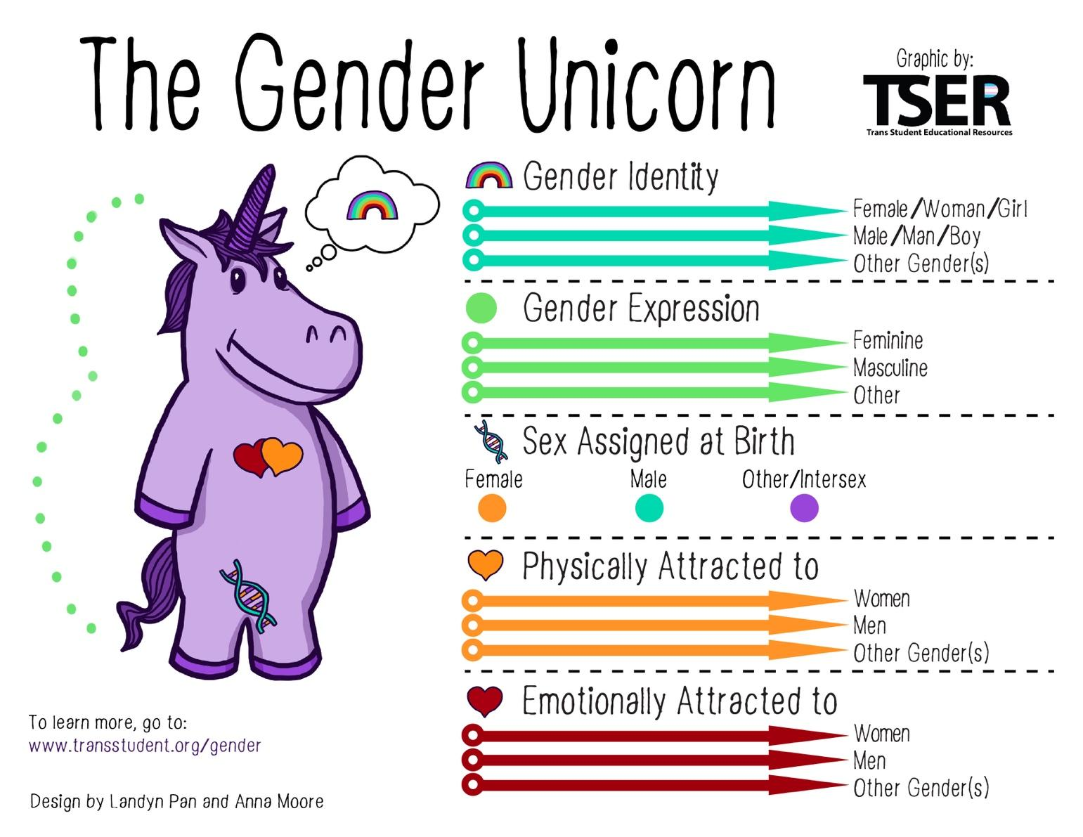

As these concepts are further understand, by the people experiencing them as well as by the population at large, then it is likely definitions, nuances, and experiences will change. Remember this is an ever-shifting construct that encompasses a social and political identity. Gender has always fallen into these systems, and we have to err on the side of compassion and understanding rather than rigid institutional definitions. Think of who needs to be centered in these conversations, and what is at stake.

## Language and Gender

* People who think their gender identity matches their sex-assigned-at-birth are referred to as cisgender (). Cisgender has its origin in the Latin-derived prefix cis-, meaning "on this side of", which means the opposite of trans-, meaning "across from" or "on the other side of".

*Source: Cisgender -* [*https://en.wikipedia.org*](https://en.wikipedia.org/wiki/special:search/Cisgender)

* No one is is “cisgendered” or “transgendered” and the terms should not stand in as a replacement for person. So it is always “cisgender person” or “transgender folx” and never “a transgender”.
* Familiarization with the terminology of gender theory should be made a priority for all volunteers and ChickTech members. [Transstudent](http://www.transstudent.org/definitions) has provided a great list, with plain-spoken definitions. Additional sources will be in the Further Reading section, though it is not possible to have an exhaustive list.
* Bigender is when someone identifies as two or more genders. This is not the same as Two-Spirit which remember is a spiritual and ceremonial designation from some Indigenous tribes.
* “Guys” is not a gender-neutral term. There is no school of thought that agrees that it is, and many that demonstrate it isn’t. It doesn’t mean you have to stop using it, or that you are wrong for doing so. Just be frank with yourself, and mindful. Try to encourage your participants to find other phrases.

### Possible Pronouns

* She/her
* He/him
* They/them
* Hir
* Zhe

## Further Reading and Resources